**Logbook (2020)**

|  |  |  |
| --- | --- | --- |
| Entry | Date | Rating |
| Tutorial: Getting Started in Unreal Engine (Part 1) M | 02.01 | Exemplary |
| Tutorial: Getting Started in Unreal Engine (Part 2, 3) M | 03.01 | Exemplary |
| Tutorial: Getting Started in Unreal Engine (Part 4) M | 05.01 | Incomplete |
| Accomplish the Expose M | 07.01 | Exemplary |
| 1st Meeting M | 10.01 |  |
| Tutorial: Getting Started in Unreal Engine (Review) M | 03.02 | Exemplary |
| Tutorial: Exploring Blueprints (Part 2, 3) M | 04.02 | Exemplary |
| Tutorial: Exploring Blueprints (Part 4) M | 05.02 | Exemplary |
| Rewrite the Expose (Specify details) M | 06.02 | Exemplary |
| Tutorial: Unreal Academy 2019 (4 Parts) M | 07.02 | Exemplary |
| 2nd Meeting M | 10.02 |  |
| GitHub and GitKraken M | 11.02 | Exemplary |
| C++ Basic Reviewing M | 12.02-14.02 | Exemplary |

**02.01.2020**

**Tutorial: Getting Started in Unreal Engine (Part 1)**

Reflections: Understand well.

**Part 1: Your First Hour with Unreal Engine**

1. **Welcome to the launcher**

Epic Games Launcher

Home: see hottest games available from the Epic Games store

Store: list games and purchase games

Library: manage games you have purchased

Friends: networking tools, build the list of friends and co-workers

Unreal Engine: developer area of the launcher

Unreal Engine: lists everything new and exciting, focus on development

Learn: suggested learning resources, hotlinks to documentation

Marketplace: free and paid content

Library: engine version, project list

1. **Creating your first project**

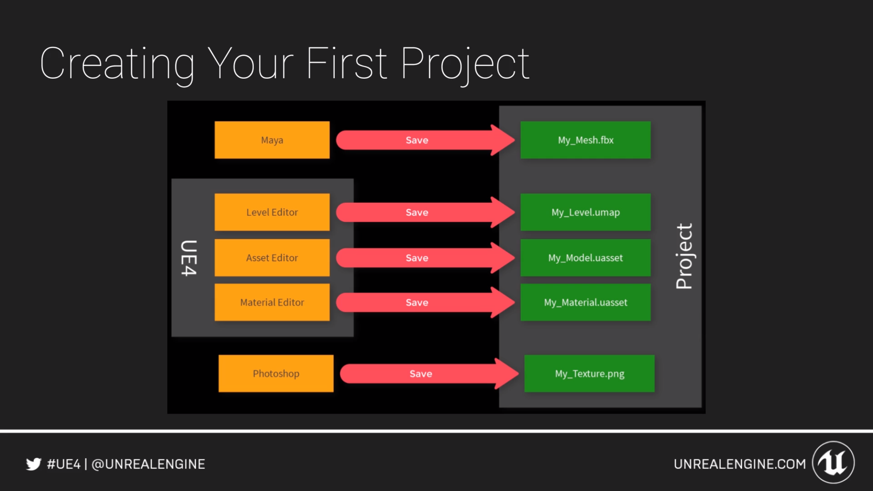

Useful hotkeys:

W, E, R: move, rotate, scale

G: toggle game mode

Ctrl+1: store a bookmark; 1: retrieve bookmark

F11: toggle immersive mode

F: focus selected object

1. **Working with content**

Four methods:

Starter content

Marketplace

Migrate from other projects

Import content directly

Import content directly includes:

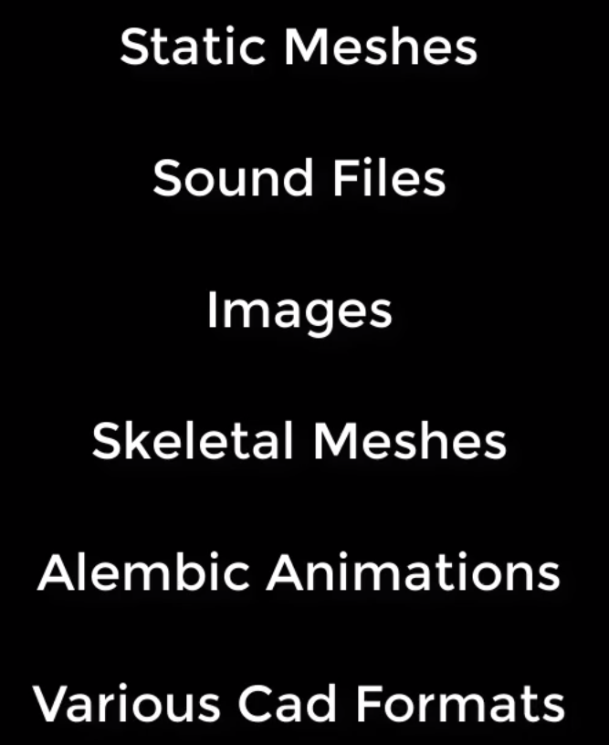

To learn more:

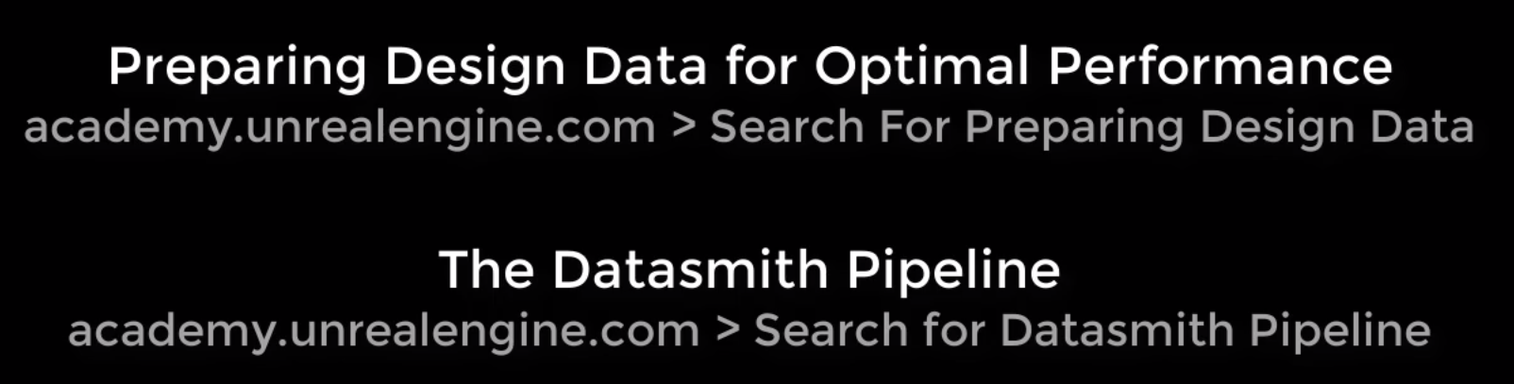

1. **Building your first level**

New folder: Levels

In the folder: Right-click 🡪 Create Basic Asset 🡪 Level

Example:

SM_Exo_Bridge: select ground

Add light: Direction Light

Alt key to duplicate ground

Modes: choose Player Start; add Atmosphere Fog; add Sphere Reflection Capture

1. **Visual Control**

Sky Light

Post Process Volume: Details 🡪 check Infinite Extent

BP_Sky_Sphere

Put in one folder: !World Lighting

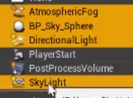

1. **Actor**

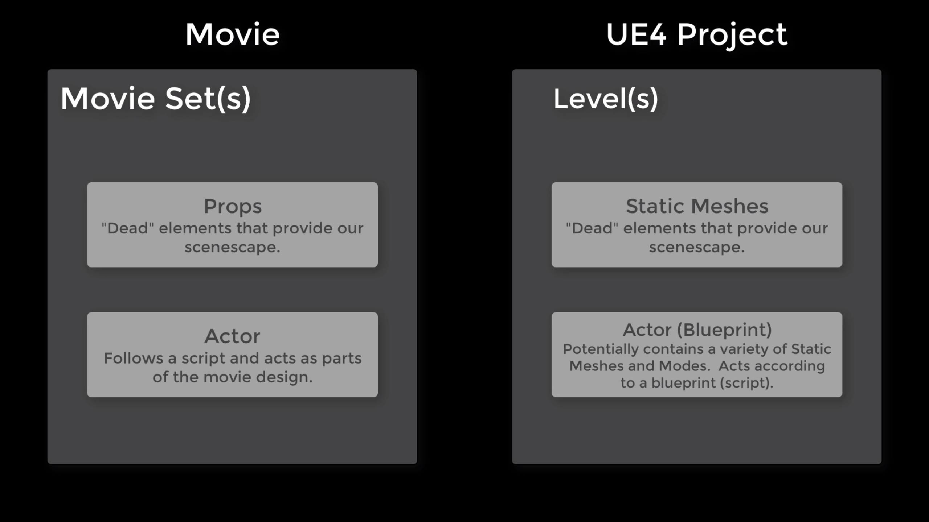

New folder: BP_Actors

Right-click: Blueprint Class 🡪 Actor 🡪 name BP_Lamp

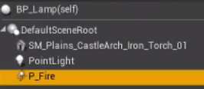

After accomplish: compile and save

Event graph:

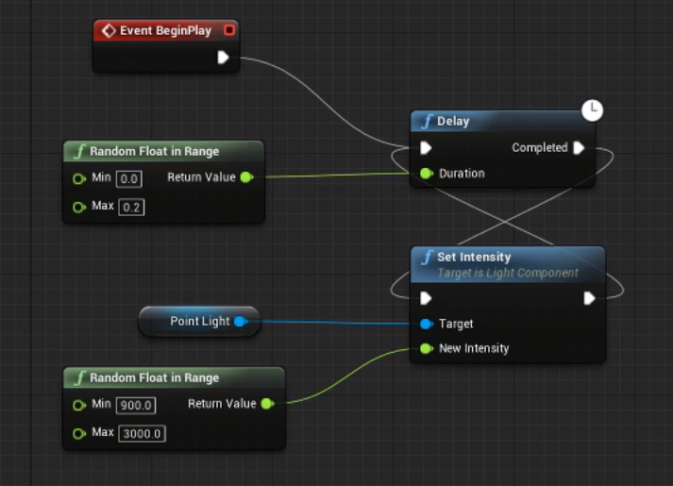

**3.1.2020**

**Tutorial: Getting Started in Unreal Engine (Part 2 & 3)**

Reflections: Understand well.

**Part 2: Introducing Unreal Engine**

1. **Editor Basics Introduction**

Overview: Editor layout customization

Viewpoint: Options navigation

World Outliner: How it works

Detail Panels: What it does features

Modes Panel: Available modes; place modes

Content Browser: What is it for customization

Main Toolbar: Shortcuts to common actions

1. **Editor Basics Overview**

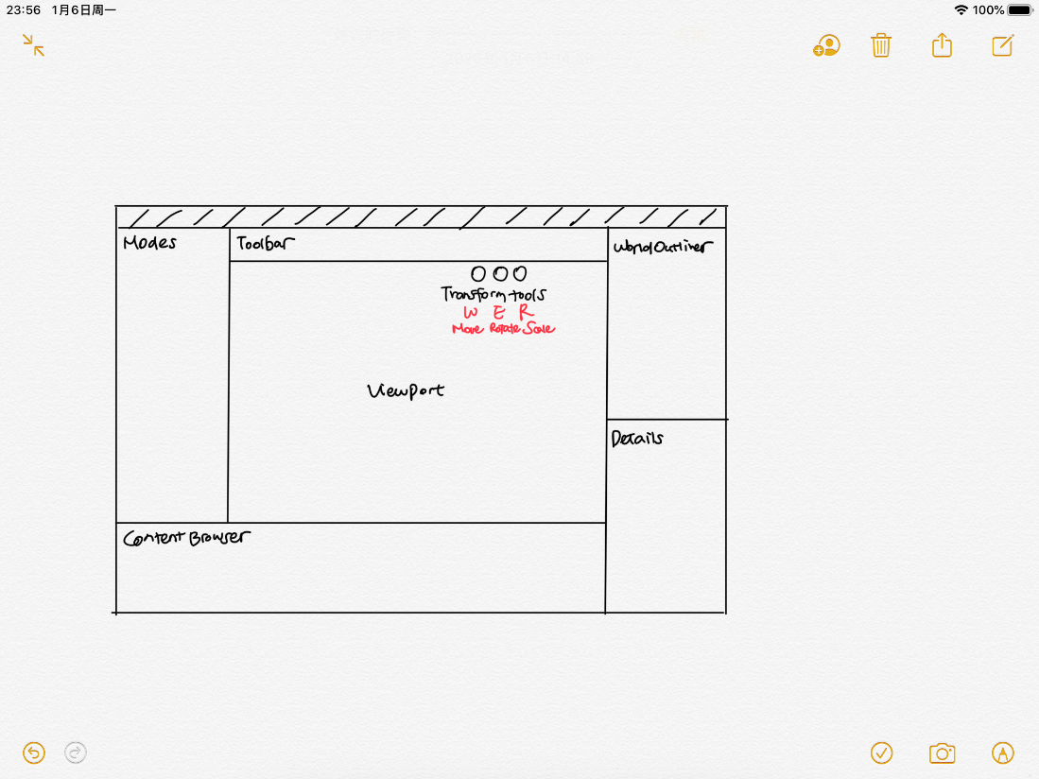

Window 🡪 Reset Layout

1. **The Viewport**

Transform Tools: WER

Change view: Use mouse or WASD QE

1. **World Outliner**

The World Outliner is a hierarchy of all the items in a level, and it provides tools for selecting, searching, deleting, parenting, grouping, and displaying/hiding items.

1. **Detail Panel**

The Details panel shows items selected, components, and their properties. On the Details panel, you can change property values, add components, and convert chosen items to Blueprints. You can also use multiple Details panels to match properties between objects.

1. **Modes Panel**

The Modes panel gives access to operation such as Place for adding common objects to your scene, Paint, Landscape, Foliage, and Mesh Editing. Being in a particular Mode affects the available options in other panels in the Modes tab.

1. **Content Browser**

The Content Browser displays and organizes all your content in your project, including geometry, blueprints, and textures. The Content Browser shows the content in your folders, and the view can be filtered to find specific items. You can open up to four Content Browsers.

1. **Main Toolbar**

The Main Toolbar provides quick access to your project and its settings and provides you with the ability to Build changes such as lighting and navigation. It also offers a quick way for Play-test your project.

1. **Editor Basics Conclusion**

In the previous section, you learned how to customize and reset the Editor, use snap and navigation in the Viewport, work with items in the World Outliner, adjust properties in Details panel, use Place mode to place objects, and use the Content Browser to organize your content.

1. **Settings Overview Introduction**

Editor Preferences

Project Setting

World Setting

1. **Editor Preferences**

Edit 🡪 Preferences: Region & Languages; Tutorial

1. **Project Settings**

The Project Settings allows you to set modes, maps, and rendering options. It enables effects or optimizations for a particular target platform.

1. **World Settings**

Window 🡪 World Settings

With World Settings, you can override settings such as vertical level, gravity, and light settings for the entire current level.

1. **Settings Overview Conclusion**

Editor preferences: appearance of the graph editors; options when playing in editor; editor options

Project settings: project information; maps and modes; input; rendering

World settings: override game mode; gravity; light mass

**Part 3:** **Comprehending Projects and File Structure**

1. **Introduction to the Launcher**

The Launcher

Community Tab

Learn Tab

Marketplace Tab

Library Tab

Modding Tab

1. **Welcome to the Epic Games Launcher**

Overview of the Epic Games Launcher

1. **The Epic Games Launcher Conclusion**

Review of the Epic Games Launcher features

1. **Introduction to Projects & Templates**

Managing our projects: finding; working

Getting started: creating; templates; starter content; feature packs

Project settings: new project; commonly changed; important

1. **Managing Your Projects**

Old project with lower edition: open a copy/convert in-place/skip conversion

1. **Starting a New Project**

Starter content: ~500MB

1. **The Project Settings Overview**

Project Settings 🡪 Target Hardware or Maps & Modes

1. **Projects & Templates Conclusion**

Manage & Create

Templates & Features

Starter Content

Projects Settings

1. **Introduction to Important Files and Folders**

.uproject File

Project Folder Structure

Cached Downloads

DDC Folders

1. **Understanding the .uproject File**

Includes basic settings of how this project interacts with the engine

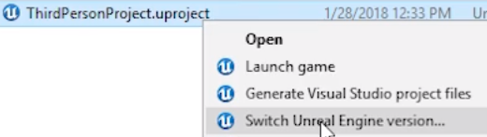

1. **Understanding Project Structure**

Blueprint Project:

Not necessary: intermediate

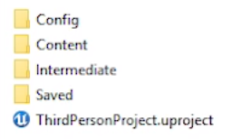

C++ Project:

Not necessary: .vs; binaries; intermediate; .sln

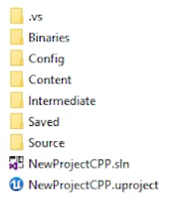

1. **Cached Downloads**

Vault Cache Location

1. **DDC Folders**

Derived Data Cache: stores versions of your assets in the specific format that is used by UE4 for the target platform



1. **Important Files and Folders Conclusion**

**05.01.2020**

**Tutorial: Getting Started in Unreal Engine (Part 4)**

Reflections: The part of textures and materials is too hard to understand. I’ll watch these parts again later.

**Part 4: Building Better Pipelines**

Material: https://epicgames.ent.box.com/s/1bykqw0c4do5k4nlprlmjwwhr64x7qwn

1. **Source Control**

Overview:

Working with others

Building better 3D meshes & textures

Creating materials & material instances

Performance & optimization

Source control:

Perforce, Subversion: sync data; add/remove data; revert data

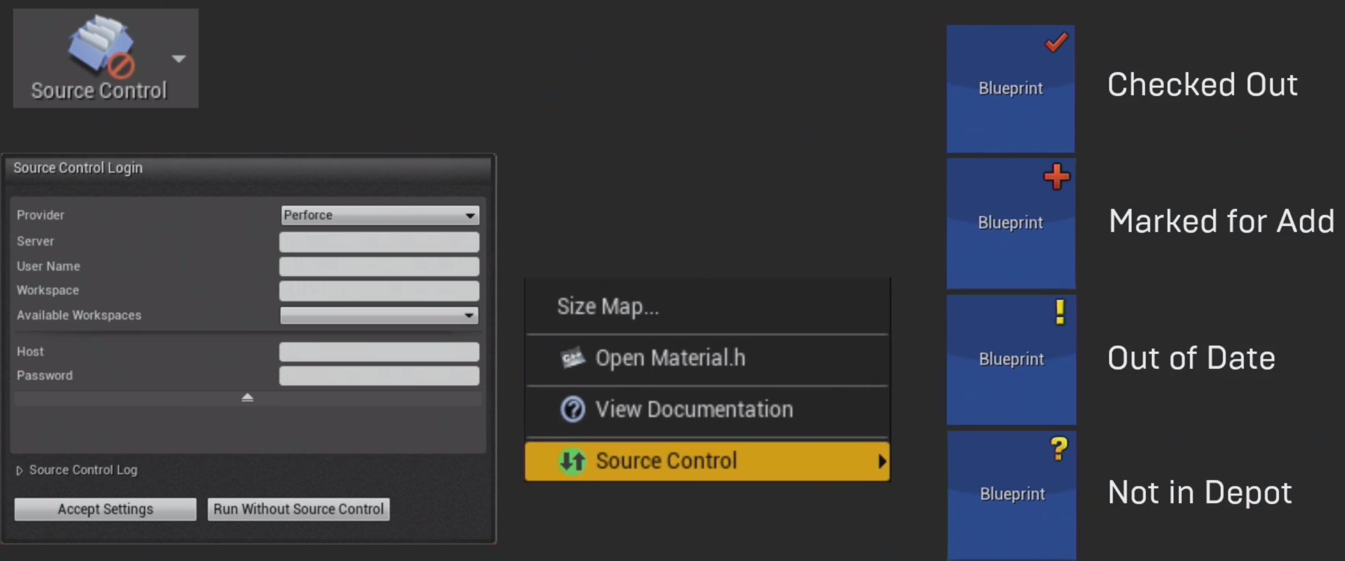

1. **Textures**

Naming conventions

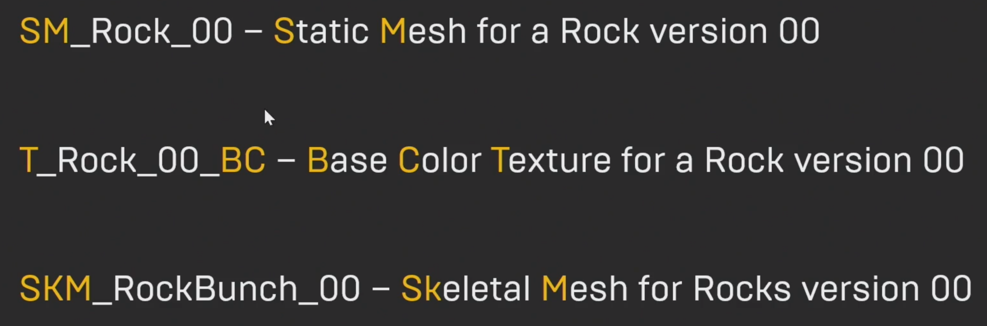

Texture creation

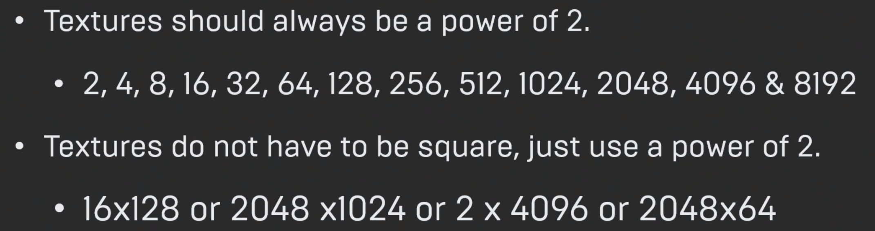

Alpha information

Embed alpha or separate alpha

RGB mask packing

A way to cut down on the amount of textures and memory used

Saving textures

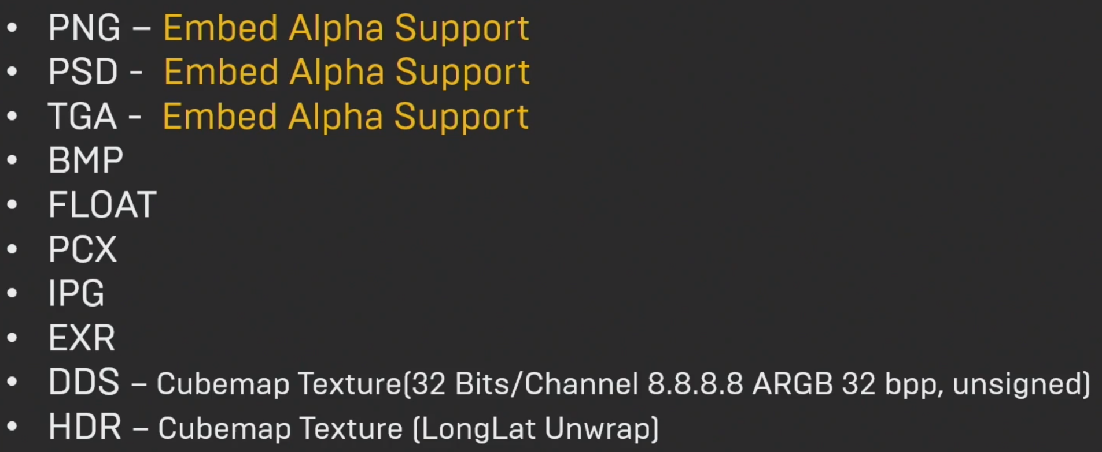

MIP mapping

Level of details for your textures

Important textures

2 ways: drag & drop; import button

Texture groups

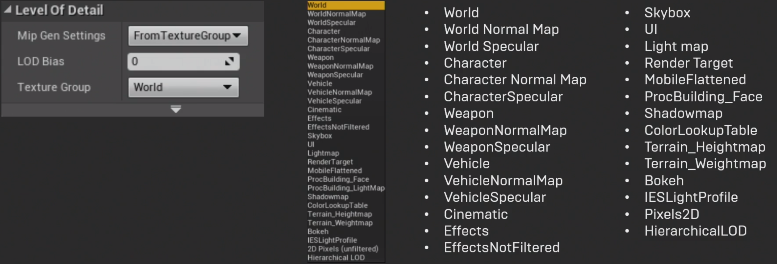

Texture compression

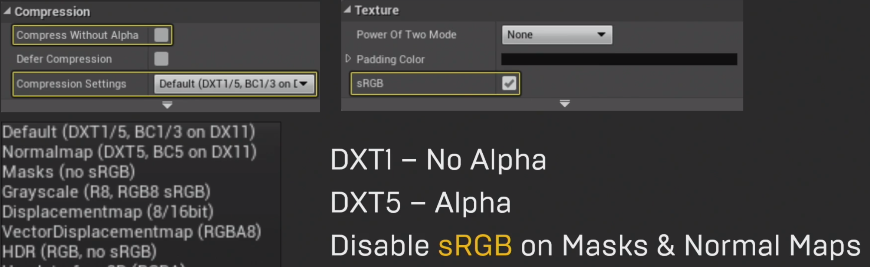

**07.01.2020**

**Accomplish the Expose**

Reflections: Just outline. The detailed project to be done and the schedule need to be reconsidered later.

**10.01.2020**

**1st Meeting**

Reflections: Talk about the following things. I’ll prepare these things after examination.

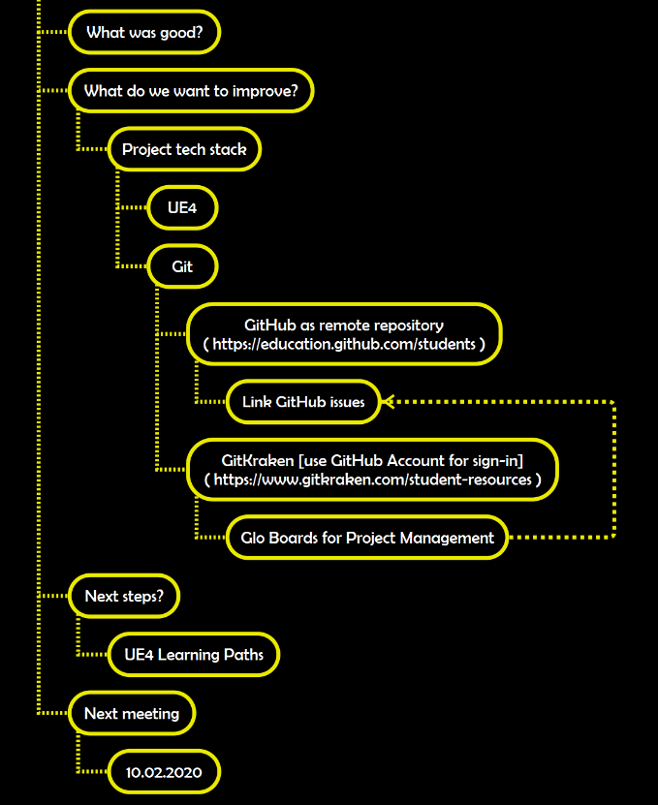

**03.02.2020**

**Tutorial: Getting Started in Unreal Engine (Review)**

Reflections: Review all parts of the tutorial. Also watch the last part in detail.

**Part 4: Building Better Pipelines (continued)**

First review the former knowlwdge.

1. **Static Meshes**

System Units

UE4 use Centimeters for unit of measurement

1 Unreal Unit = 1 Centimeter

Triangle Counts

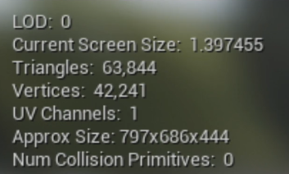

Material ID’s

Each material ID you have will make the model more expensive to render

Pivot Points

Usually 0,0,0

What Are Lightmaps

Used to store complex light and shadow information inside of a texture

Lightmap UV’s

0 to 1 UV Space

Collision Meshes

Used in physical simulation

Convex Decomposition

What Are LOD’s

Level of Detail: lower triangle versions of the same maps

Help lower the rendering cost of distance objects

Creating LOD’s

By hand or programmatically

Limiting Overdraw

Refers to your GPU having to draw a bunch of transparent or see-through areas of the texture which do not actually display any useful information

1. **Exporting and Importing**

Exporting Static Meshes

Exporting Skeletal Meshes

Export using the FBX format

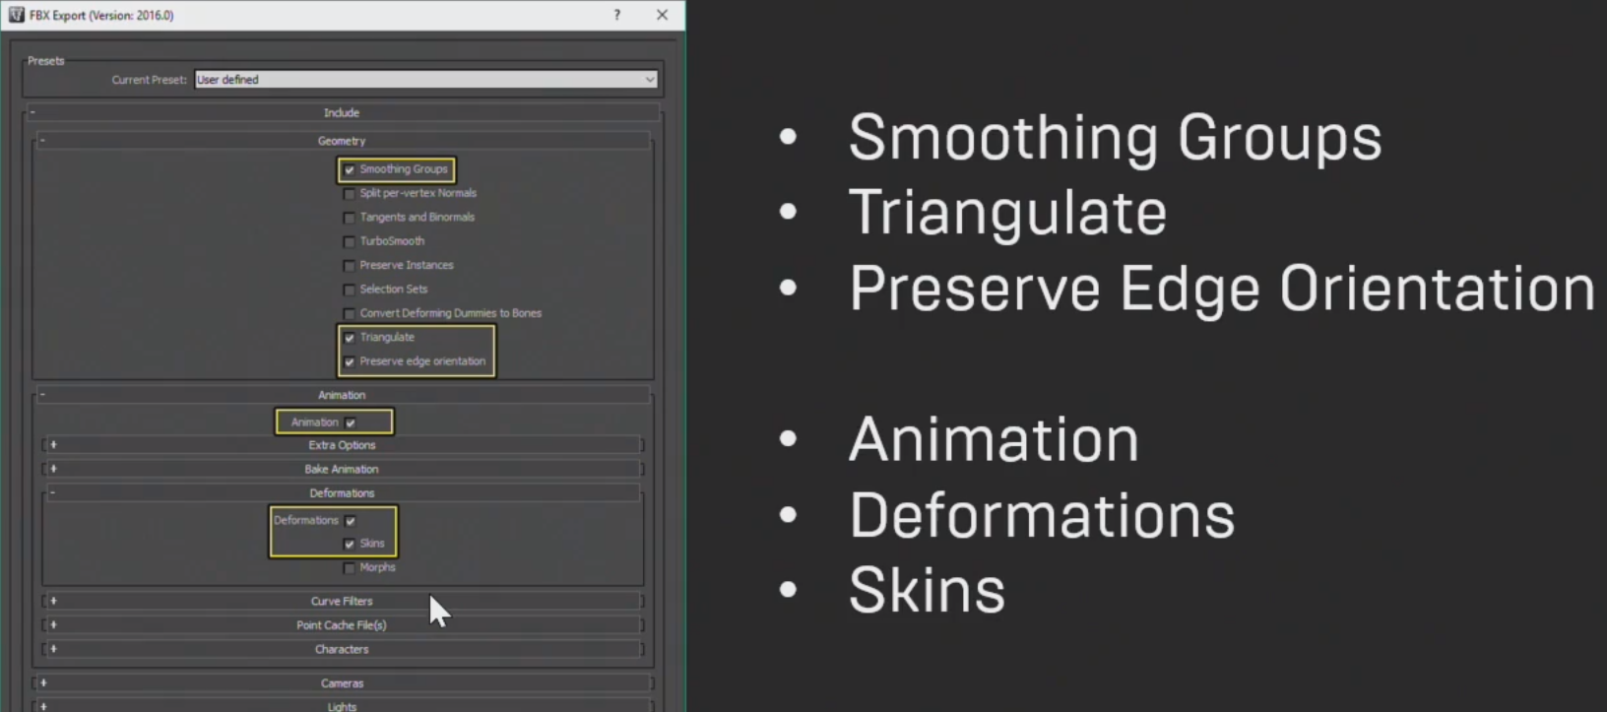

3D Mesh Import

3D Mesh Import Options

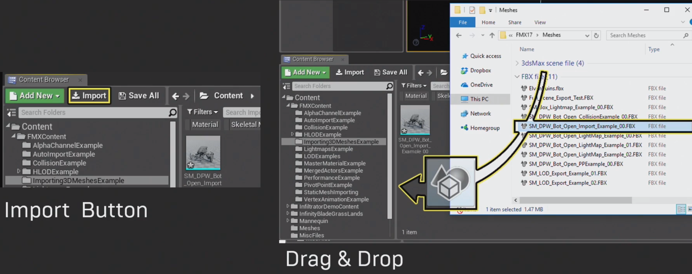

Re-Importing Assets

Auto Re-Import

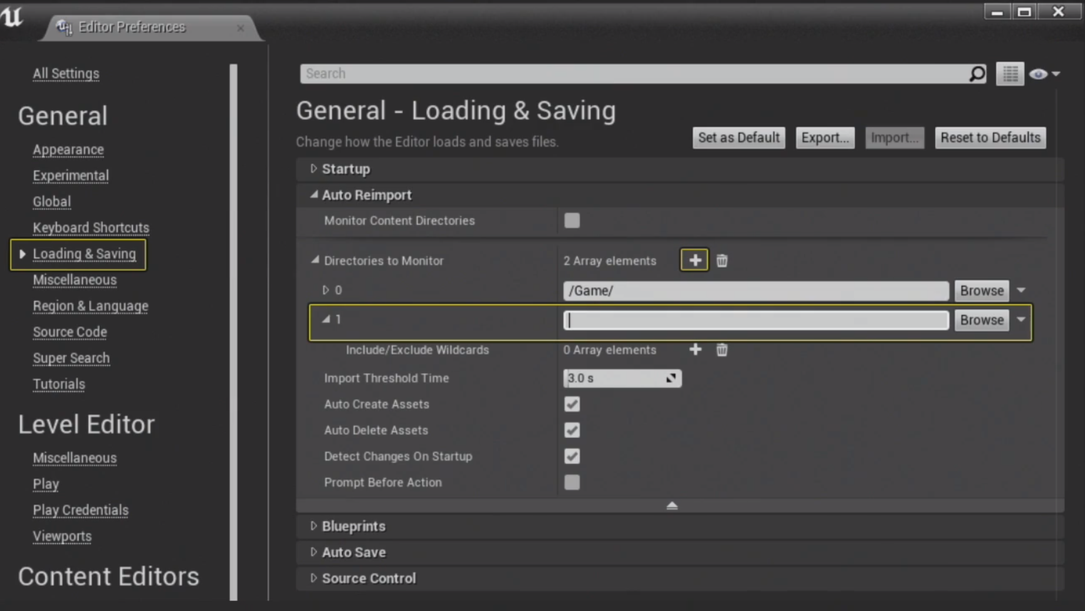

Full Scene Import

Exporting Assets from UE4

1. **Materials Part 1**

PBR: Physical Based Rendering

Material Domain

Material/Material Instance

Master Material

1. **Materials Part 2: Master Materials and Material Functions**

Setting up a Master Material for Environment Objects

Setting up a Master Material for Glass

Creating & using Material functions

1. **Materials Part 3: Using Material Instances**

Part 1:

Parent/Master Materials and their children

Creating & Using Material Instances

Overriding Parent Material Functionality

Part 2:

What is Vertex Animation

Why you would want to use Vertex Animation

How to setup and use Vertex Animation in Materials

1. **Texture Streaming**

Texture Streaming helps to organize different levels of texture detail as the texture gets further or closer to the camera.

1. **LODs & Merging Static Meshes**

Level of Detail or LOD

Merge Actor Tool

Hierarchical Level of Detail or HLOD

1. **Lighting, Shadowing & Post Process**

Lighting

Movability: Static; Stationary; Movable

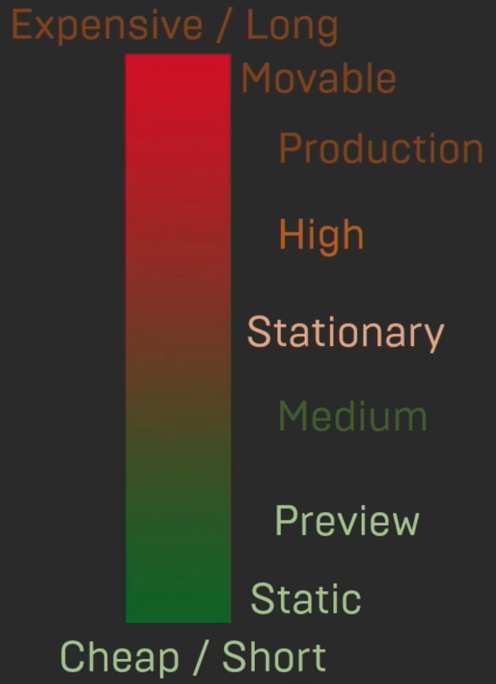

Shadow

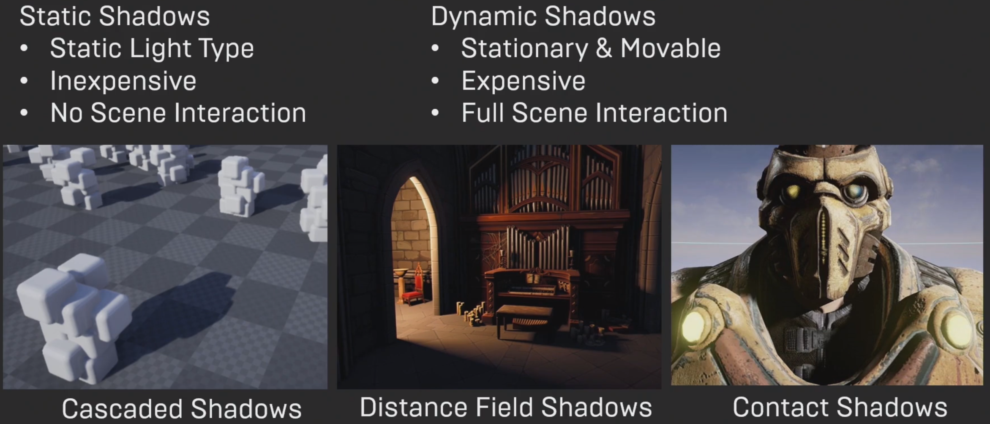

Post Process

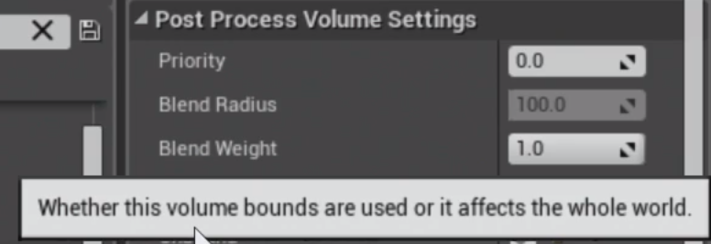

1. **Volumes**

Volumes

Lightmass Volumes

Cull Distance Volumes

1. **Reflections**

Reflections require extra levels of calculation, and can greatly impact performance.

Reflections Actor Types

Screen Space Reflections

Sphere Reflections

Box Reflections

Planar Reflections

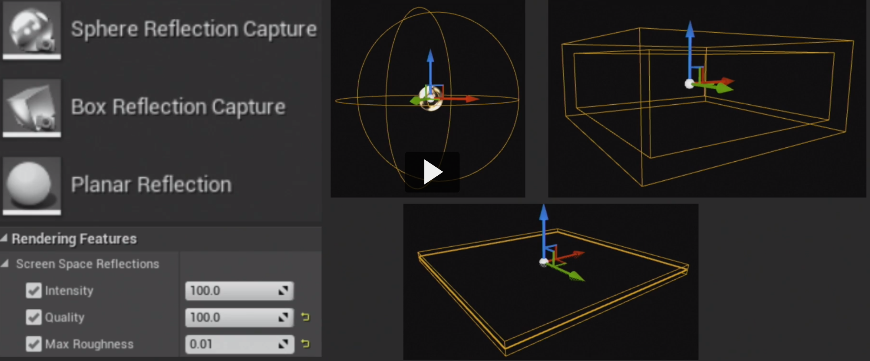

Getting Higher Quality Reflections

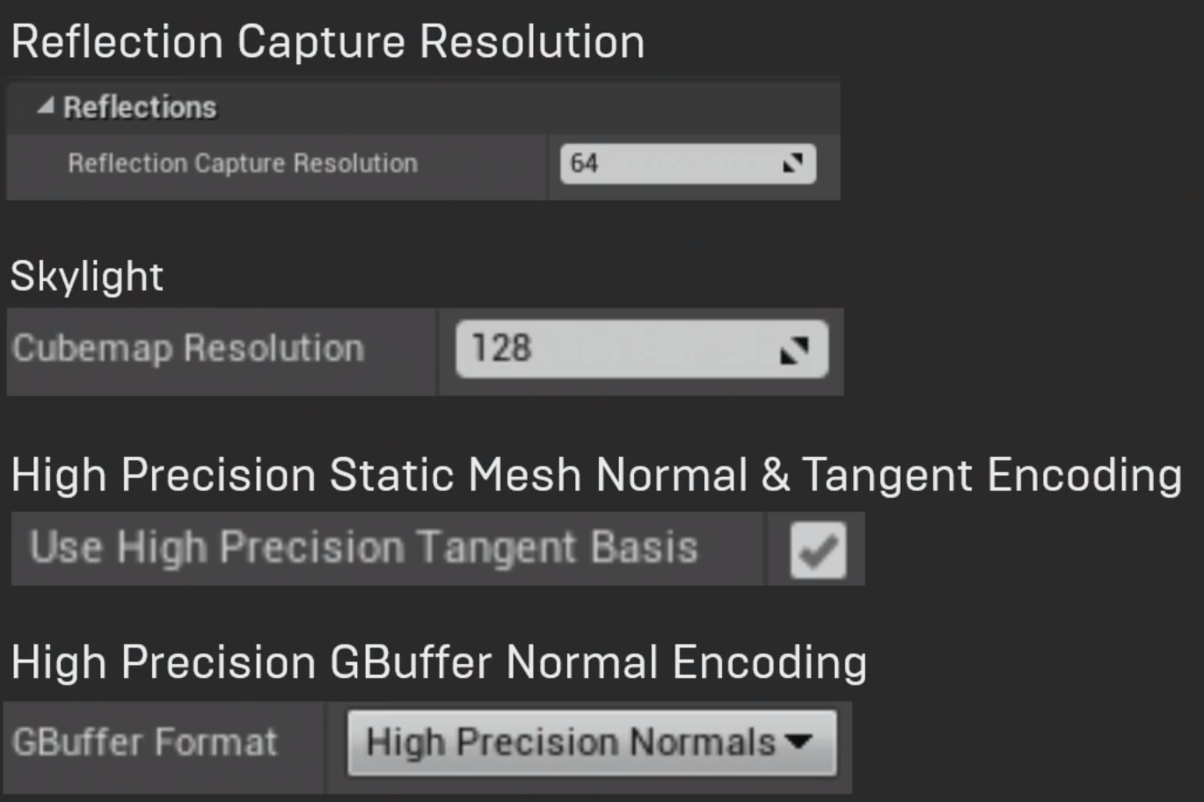

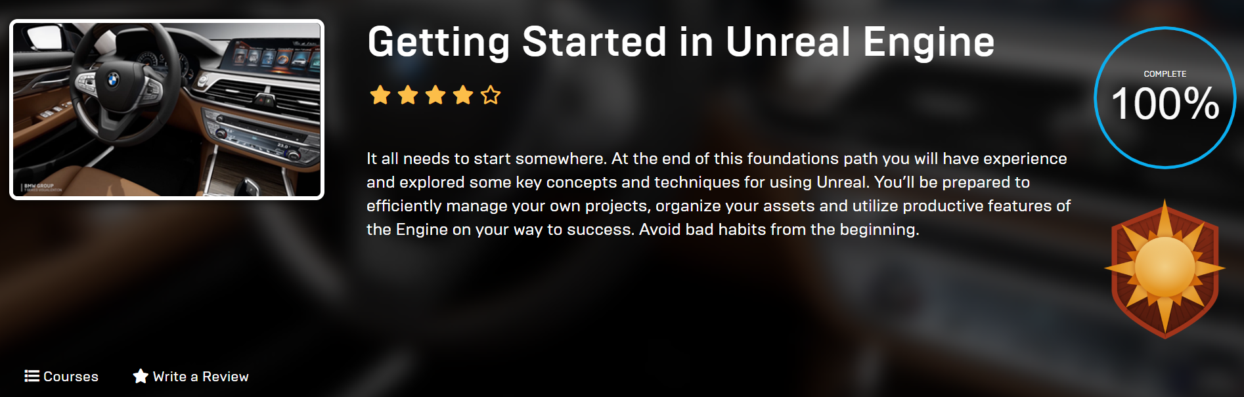

**04.02.2020**

**Tutorial: Exploring Blueprints (Part 2, 3)**

Reflections: Understand but need to exercise more. The part highlighted in yellow may be useful for my future project.

**Part 2: Blueprints - Essential Concepts**

Material: https://epicgames.box.com/s/zz9ydnf9bfgdhk771w6z1ss5ldit2dzp

1. **Introduction to Blueprint Essentials**

Introduce outline

1. **What is Blueprint?**

Blueprint is visual scripting, object-oriented visual scripting language

Think of Blueprints as a container for content: hold components, script, data

Types: Level/Class Blueprint

1. **Creating Blueprints and Editor UI**

UI: Viewport; Construction Script; Event Graph

1. **Blueprint Components**

Default Scene Root

Static Mesh

Skeletal Mesh

Multiple Components

1. **Blueprint Graphs**

Simple event graph:

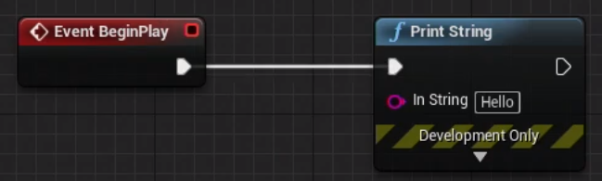

Comment: select and push “C”

Collapse to function/Macro/Nodes:

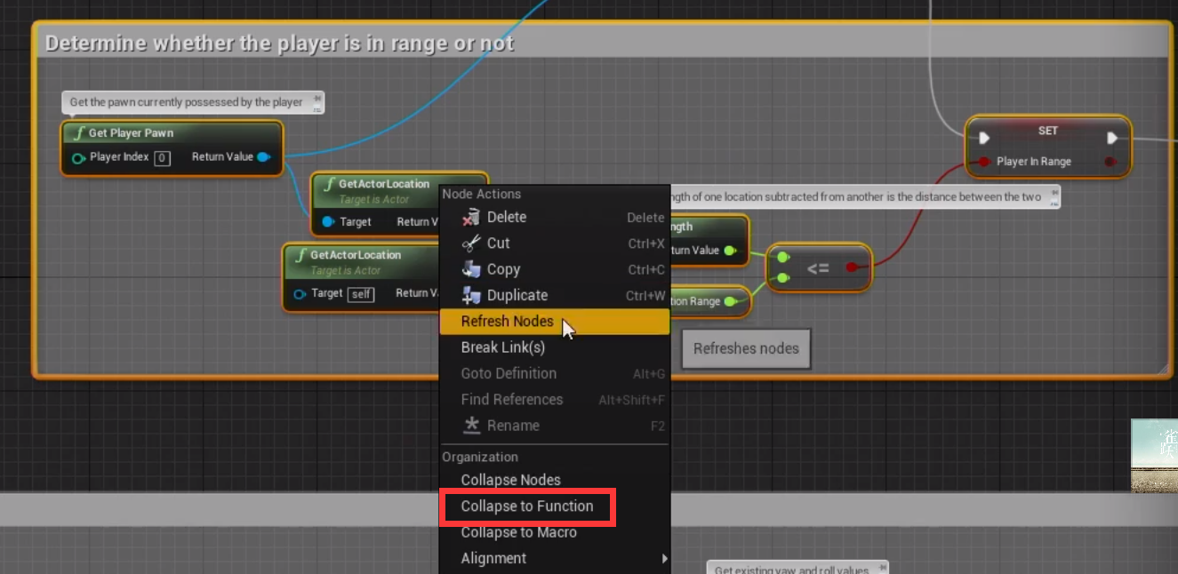

1. **Exploring Different Types of Blueprints**

Level Blueprint

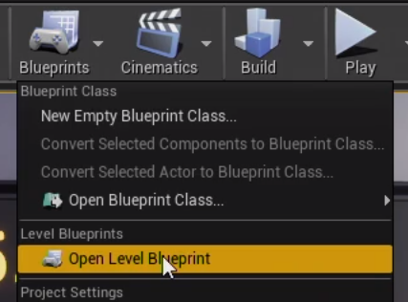

Actor Blueprint

Animation Blueprint

UMG UI

Child Blueprint

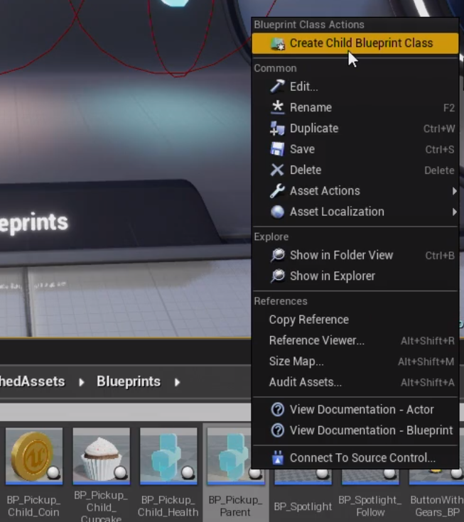

1. **Caveats to Using Blueprint**

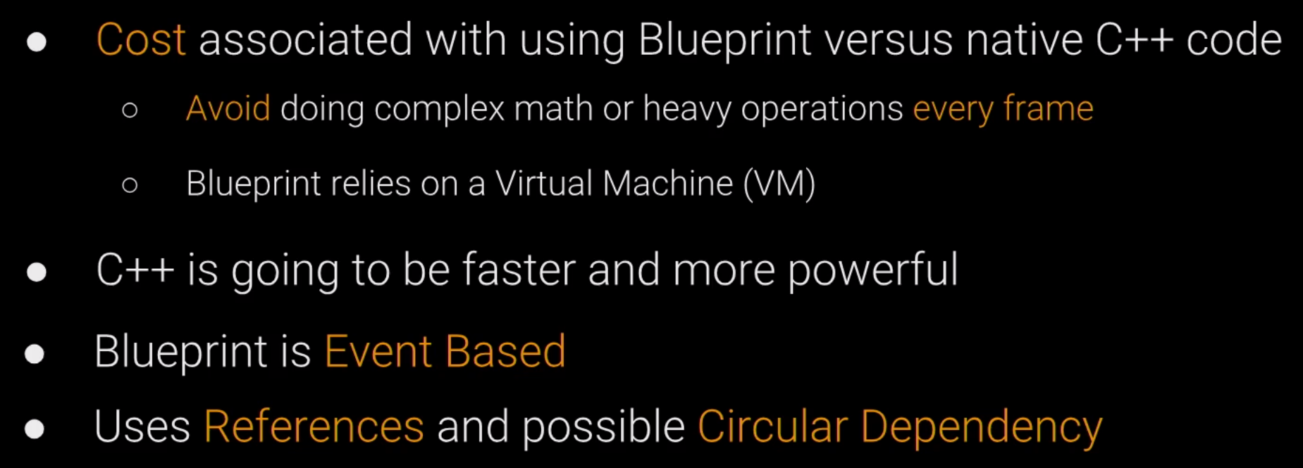

Potential Problems:

References

Casting

Circular Dependency

1. **Wrapping up Blueprint Essential Concepts**

Recap the topics that were covered

1. **Additional References**

Blueprint Essentials

* [Blueprint best practices](https://docs.unrealengine.com/en-US/Engine/Blueprints/BestPractices/index.html)
* [Editor Cheat Sheet](https://docs.unrealengine.com/en-US/Engine/Blueprints/UserGuide/CheatSheet/index.html)
* [Blueprint How-tos](https://docs.unrealengine.com/en-US/Engine/Blueprints/BP_HowTo/index.html)
* [Anatomy of a Blueprint](https://docs.unrealengine.com/en-US/Engine/Blueprints/Anatomy/index.html)
* [Blueprint Workflow](https://docs.unrealengine.com/en-US/Engine/Blueprints/Workflow/index.html)
* [Introduction to Blueprints](https://docs.unrealengine.com/en-US/Engine/Blueprints/GettingStarted/index.html)
* [Blueprint Editor Reference](https://docs.unrealengine.com/en-US/Engine/Blueprints/Editor/index.html)

Anatomy of a BP

* [Variables](https://docs.unrealengine.com/en-US/Engine/Blueprints/UserGuide/Variables/index.html)
* [Blueprint Classes](https://docs.unrealengine.com/en-US/Engine/Blueprints/UserGuide/Types/ClassBlueprint/index.html)
* [Actors](https://docs.unrealengine.com/en-US/Programming/UnrealArchitecture/Actors/index.html)
* [Using Blueprint Nodes](https://docs.unrealengine.com/en-US/Engine/Blueprints/UserGuide/Nodes/index.html)
* [Functions](https://docs.unrealengine.com/en-US/Engine/Blueprints/UserGuide/Functions/index.html)
* Adding Components to Blueprints
* [Blueprint Macros](https://docs.unrealengine.com/en-US/Engine/Blueprints/UserGuide/Macros/index.html)
* [Collapsing Graphs](https://docs.unrealengine.com/en-US/Engine/Blueprints/BP_HowTo/CollapsingGraphs/index.html)
* [Construction Script](https://docs.unrealengine.com/en-US/Engine/Blueprints/UserGuide/UserConstructionScript/index.html)

Going Beyond

* [Blueprint Communication](https://docs.unrealengine.com/en-US/Engine/Blueprints/UserGuide/BlueprintCommsUsage/index.html)
* [Blueprint Macro Library](https://docs.unrealengine.com/en-US/Engine/Blueprints/UserGuide/Types/MacroLibrary/index.html)
* [Blueprint Projects Quick Start](https://docs.unrealengine.com/en-US/Engine/Blueprints/QuickStart/index.html)
* [Example Blueprints](https://docs.unrealengine.com/en-US/Resources/Showcases/BlueprintExamples/index.html)

Reference Guides

* [Technical Guide for programmers](https://docs.unrealengine.com/en-US/Engine/Blueprints/TechnicalGuide/index.html)

**Part 3: Interactive Material Swaps Using Blueprints**

Free Demo:

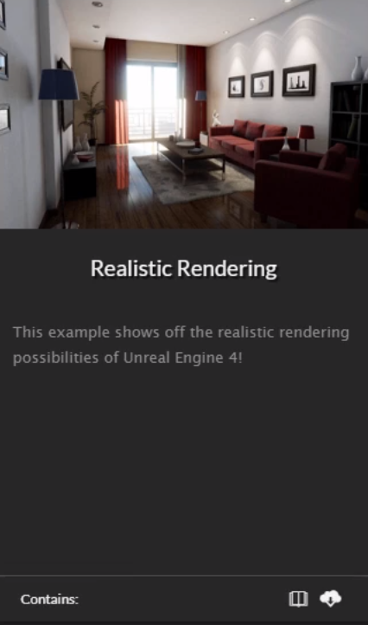

1. **Introduction and Material Collections**

Add Material Collection:

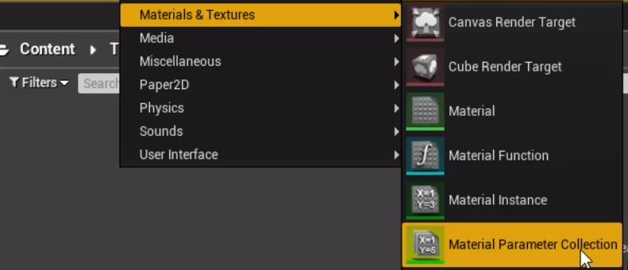

1. **Creating a Widget to Control our Material Collection**

UI 🡪 Widget

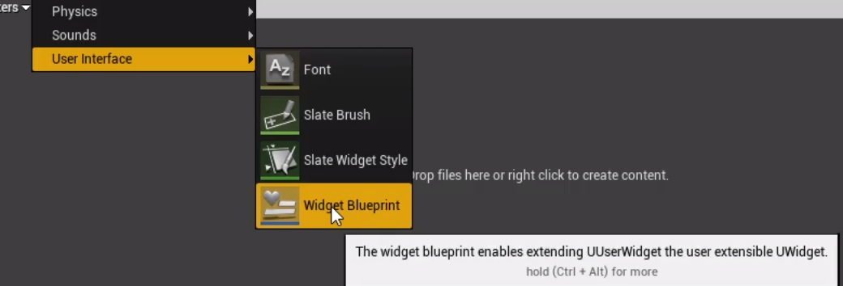

1. **Showing the Widget in the User Interface**

Add to here:

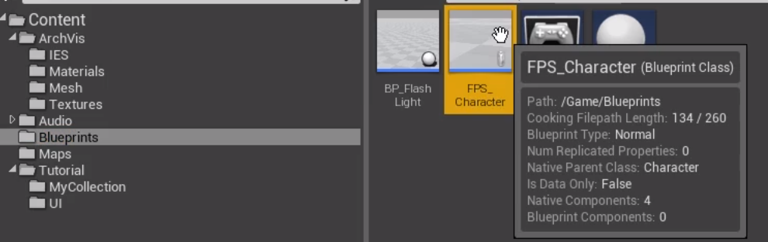

1. **Connecting the Widget Buttons to the Material Controls**

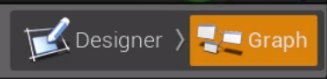

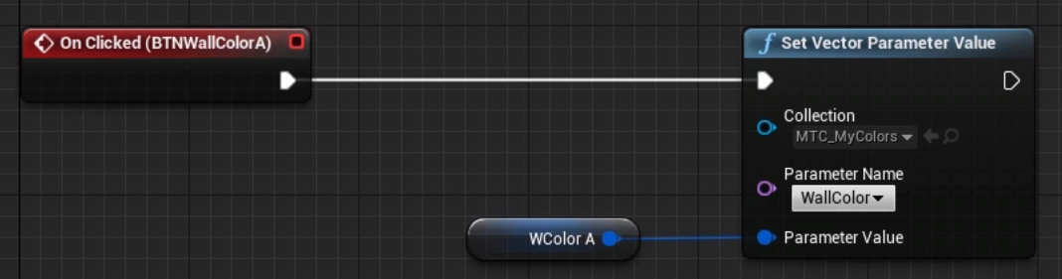

1. **Animating the UI Widget**

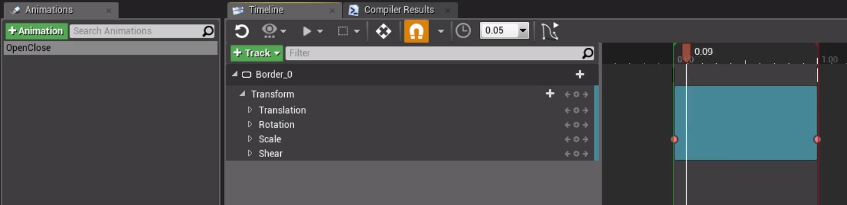

1. **Interactive Material Swaps Using Blueprints Conclusion**

Material Collection is shared with every material that uses it.

Material Parameter would only affect that specific material.

**05.02.2020**

**Tutorial: Exploring Blueprints (Part 4)**

Reflections: This project is so cool! I need exercise it step by step later.

**Part 4: Blueprint for Enterprise**

Material: https://app.box.com/s/ahi0tzzlxyuvzca2fgwujsu4qoz8yqfh

1. **Introduction to Blueprint for Enterprise**
2. **What is a Blueprint?**

A Blueprint is an object that inherits functionality its Parent Class, such as an Actor or Pawn, and extends that functionality with assets and node-based programming in a graph.

1. **Blueprint Event Graphs**

Event Graphs hold all the Blueprint code that handles events in your game, such as Begin Play and when a controller button or keyboard key is pressed.

Enable Input:

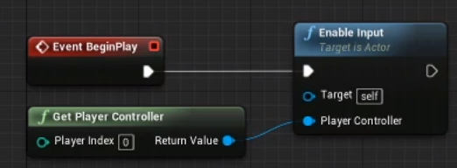

1. **Level Blueprint**

A Level Blueprint, unlike a Blueprint Object, is an Event Graph that is part of your level and allows you to handle events from a master location.

1. **Functions**

A function is a type of container, one that holds reusable Blueprint nodes. A Function can be used by numerous Blueprints and can simplify your code.

1. **Variables and Arrays**

A variable is a container for data such as character strings, numbers and arrays.

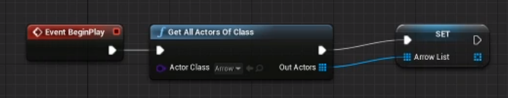

1. **DataTables**

A DataTable (read only) is like a spreadsheet of values that can be fed into inputs in a Blueprint.

1. **HUD (Heads-Up Display)**

A HUD (Heads-Up Display) provides text and other feedback to the user.

1. **Bringing It All Together**

To create a product configurator

1. **Game Mode**

Target: set up a still camera and enable the mouse

Game Mode and Player Controller Blueprint:

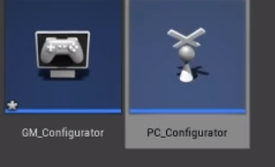 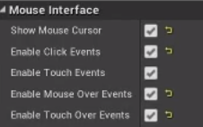 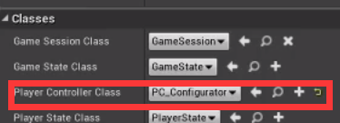

1. **Creating the Speaker Blueprint**
2. **Receiving Clicks on Our Speakers Using the Event Graph**

Events are sent to and handled by the Event Graph.

Add and group on click events.

1. **Material Swapping Part A: Building a Controller Blueprint**

Controller Blueprint: control other blueprints

1. **Material Swapping Part B: Initializing Our Blueprints**

To communicate between the speakers and speaker logic, we will need to pass references to our objects.

1. **Material Swapping Part C: Responding to Control**
2. **Enabling and Disabling the Cover Screen on Startup**

Enable and disable the Screen Cover object using a public Boolean variable

1. **Swapping Materials on the Speaker**
2. **Swapping Materials on the Accents**
3. **Adjusting the Color of the Cover Screen and Final Troubleshooting**
4. **Cleanup and Review**

Completed

1. **Creating a HUD**
2. **Importing DataTables**

Price should be Integer

1. **Preparing Our HUD for Dynamic Content**
2. **Setting up Communication to Our HUD**
3. **Pulling Data from the DataTables**
4. **Pushing the Data to the HUD**

Pure function:

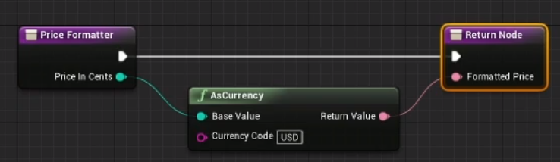

1. **Concatenate Sentences from Our Long Descriptions**
2. **Creating a Quit Button**

Add button and use image

1. **Setting up Multiple Cameras for Various Views of Our Speakers**
2. **Preparing the HUD for User Interaction**
3. **Developing Logic to Manage the Camera Interaction**

Build a gate:

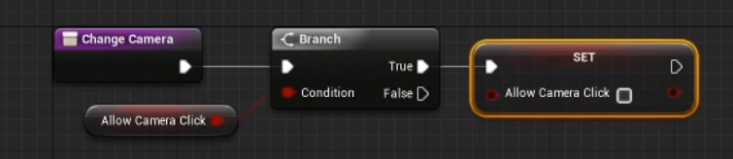

1. **Switching the Camera**

After change the camera, reset AllowCameraClick (avoid spamming buttons):

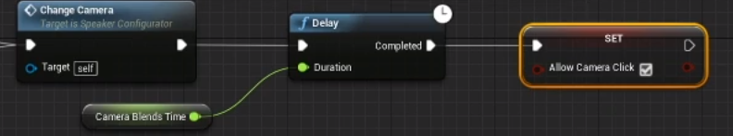

1. **Displaying a Camera Name**
2. **User Feedback with Button Sounds**

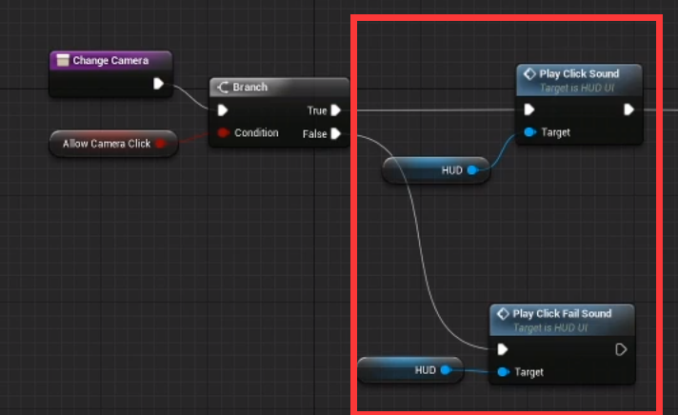

1. **Adding Music Tracks and a Simple Music Player**

Add Music Component:

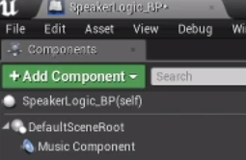

Should first stop:

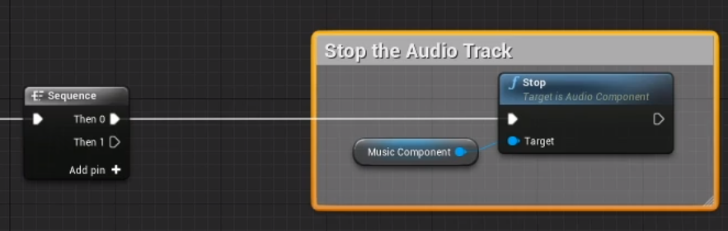

1. **Conclusion to Blueprint for Enterprise**

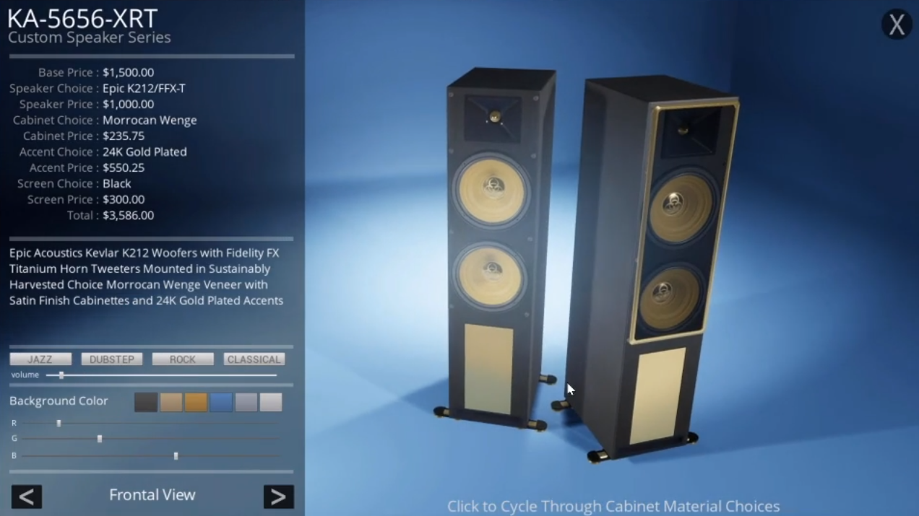

Cool!!!!!

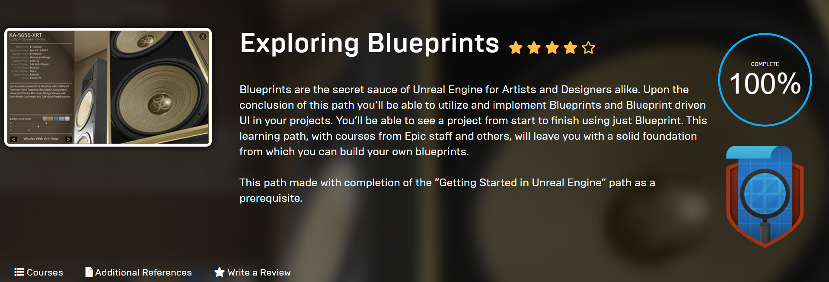

**06.02.2020**

**Rewrite the Expose (Specify details)**

Reflections: I rewrite the expose and specify the project what I’d like to make. Also reschedule my timetable.

**07.02.2020**

**Tutorial: Unreal Academy 2019 (4 Parts)**

Reflections: Just understand these knowledges. For the C++, I need to review the programming skills later.

**Blueprint In-depth**

Correct use of BP is important for: future proofing; collaboration; performance

**Mastering the Editor with Blueprints**

1. Introduction to Mastering the Editor with Blueprints
2. Creating a Template Maker
3. Creating a Viewport Bookmarker

**Using Blueprints and C++ Together**

1. The Five W's of Action RPG
2. Creating a Potion Item
3. Mixing Blueprints and C++ to Create a Pick Up
4. Dropping Loot
5. Going from Blueprint to C++ and Live++

**User Interface with Blueprint and UMG**

Goal: develop a system to switch between design alternatives using a mouse-driven user interface

UMG: Unreal Motion Graphics

Level Streaming: method for loading and unloading levels

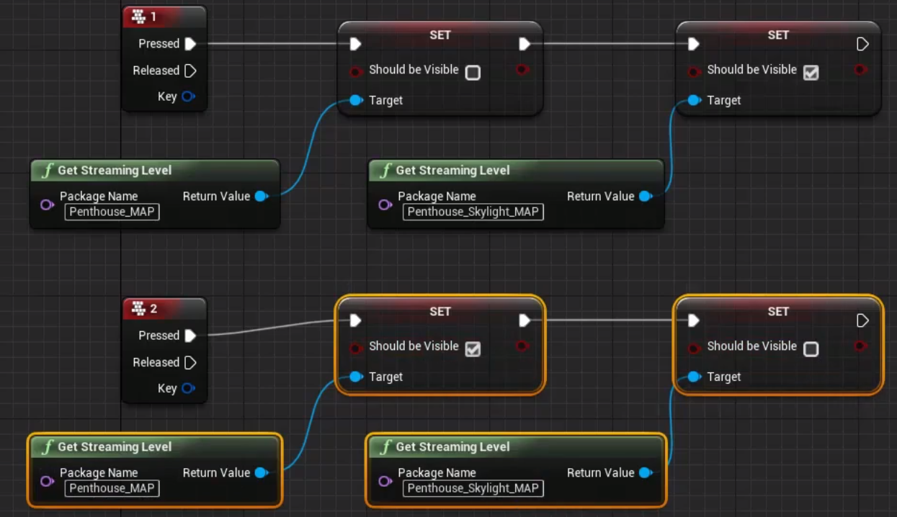

Add cursor:

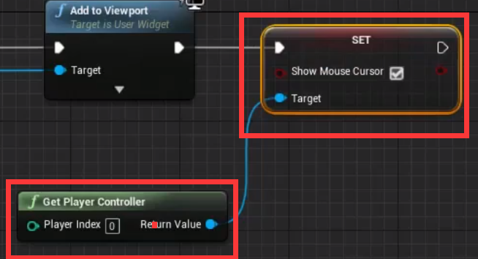

**10.02.2020**

**2nd Meeting**

Reflections: Talk about the following things. Many things to do, fighting!

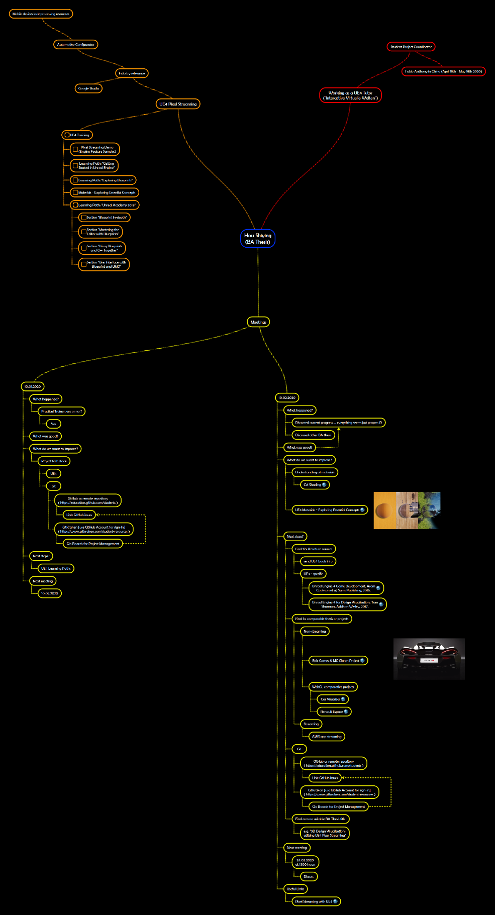

**11.02.2020**

**GitHub and GitKraken**

Reflections: SSH Error.

**GitHub**

Terms: Repository, Star, Fork, Pull Request, Watch, Issue

**12.02.2020-14.02.2020**

**C++ Basic Reviewing**

Reflections: Reviewed the basic concepts so that I can understand the code.

*C++ Primer* Chapter 1-7